Emotion Recognition System: Real-Time Facial Expression Analysis and Interactive Emotional Intelligence

Abstract

The rapid advancement of artificial intelligence and machine learning has opened new frontiers in human-computer interaction, particularly in the domain of emotion recognition. This project presents a comprehensive study of a novel emotion detection system that combines cutting-edge machine learning techniques with an interactive chat interface. By leveraging deep learning models and real-time facial analysis, the system demonstrates the potential for advanced emotional intelligence in digital platforms.

1. Introduction

1.1 Background and Context

The ability to recognize and interpret human emotions has been a long-standing challenge in computer science and artificial intelligence. Traditional human-computer interactions have been predominantly text or command-based, lacking the nuanced understanding of emotional context. The emergence of sophisticated machine learning models, particularly in computer vision and deep neural networks, has paved the way for more empathetic and context-aware digital systems.

1.2 Motivation

The primary motivation behind this research is to bridge the gap between technological interaction and emotional understanding. By developing a system capable of:
- Real-time facial emotion detection
- Contextual response generation
- Adaptive communication strategies

I aim to create a more intuitive and responsive digital interaction paradigm.
1.3 Scope and Objectives

The research focuses on developing a comprehensive emotion recognition system with the following key objectives:
- Implement a robust machine learning model for facial emotion classification
- Create an interactive chat interface that responds dynamically to detected emotions
- Develop a user-friendly web application for real-time emotion analysis

2. System Specifications
2.1 Technical Architecture
The emotion recognition system is composed of three main components: Frontend, Backend, and a Machine Learning Model, working in harmony to provide real-time emotion detection and interaction.

1. Frontend (React.js)
The frontend manages user interactions and visualizes the results.
Key Features:
- Live Video Capture:
Utilizes the user's webcam with the WebRTC API and <video> elements to capture video frames, which are sent to the backend for analysis.
- Emotion Detection Visualization:
Displays the detected emotion in real-time through dynamic UI elements like labels, emojis, or charts.
- Interactive Chat Window:
Integrates emotion-aware conversational responses.
- Responsive Design:
Built with Tailwind CSS for seamless functionality across desktops, tablets, and mobiles.

Technology Stack:
- React.js: Component-based framework for a modular and dynamic UI.
- Axios: Handles API communication with the backend.
2. Backend (Flask)
The backend is the intermediary between the frontend and the ML model, handling data processing and predictions.
Key Responsibilities:
- Model Serving:
Loads the pre-trained emotion recognition model to process input frames.
- Prediction Endpoint:
Provides RESTful APIs for receiving video frames, preprocessing them, and returning emotion predictions.
- Response Generation:
Creates personalized responses based on the detected emotions (e.g., encouragement for sadness, congrats for happiness).
- Error Handling and Logging:
Implements robust logging to monitor API usage, prediction outcomes, and errors.
Integration Tools:
- CORS Support: Enables secure cross-origin communication between the React.js frontend and Flask backend.
- Python Libraries: Supports efficient data handling and error management.
3. Machine Learning Model
The ML model is the core of the system, responsible for classifying emotions.
Model Architecture:
- Convolutional Neural Network (CNN):
Trained to recognize patterns in facial features using convolutional layers.
- FER-2013 Dataset:
The model is trained on 35,887 grayscale facial images categorized into seven emotions:
  - Angry, Disgust, Fear, Happy, Sad, Surprise, Neutral.
- Seven-Class Classification:
The model outputs probabilities for each emotion, using softmax activation in the final layer.
Preprocessing:
- NumPy: Normalizes image pixel values for optimal model performance.
- PIL (Python Imaging Library): Resizes and processes images (e.g., to 48x48 pixels) for compatibility with the model.

2.2 Technology Stack
Frontend:
- React.js: Provides a robust framework for building responsive user interfaces.
- Tailwind CSS: Ensures a clean, responsive design.
- Axios: Simplifies HTTP requests for API communication.
- Lucide React: Offers customizable icons for UI elements.
Backend:
- Python Flask: A lightweight web framework for serving APIs.
- TensorFlow/Keras: Handles the ML model's execution and prediction tasks.
- CORS Support: Ensures smooth cross-origin interactions.
Machine Learning:
- Keras Sequential Model: Implements the CNN architecture for emotion classification.
- NumPy: Efficiently processes input data.
- PIL: Handles image resizing and transformation.

3. Literature Review
3.1 Evolution of Emotion Recognition Systems
Emotion recognition has advanced significantly, evolving from basic facial analysis to complex deep learning models.
Early Systems:
- Relied on facial landmark detection, identifying key facial points like the eyes and mouth.
- Used simple rules and handcrafted features to deduce emotions, such as detecting smiles or frowns.
- Faced challenges in handling variations like lighting, occlusion, and non-standard expressions.
Modern Advances:
- Leverage deep learning techniques such as Convolutional Neural Networks (CNNs) for robust feature extraction.
- Can process diverse and dynamic inputs, including variations in pose, lighting, and complex expressions.
- Real-time systems powered by GPUs enable immediate emotion recognition.
The evolution reflects broader AI trends, emphasizing data-driven, adaptive algorithms that outperform traditional rule-based methods.

3.2 Machine Learning in Emotion Detection
Machine learning, particularly deep learning, underpins recent progress in emotion detection.
Key Developments:
- Automated Feature Extraction:
  - CNNs learn facial patterns from raw image data, capturing complex details without manual engineering.
- Model Architectures:
  - Convolutional Neural Networks (CNNs): Excellent for image-based tasks, recognizing emotional cues like smiling or frowning.
  - Recurrent Neural Networks (RNNs): Enhance emotion detection in sequences (e.g., video frames) by modeling temporal patterns.
- Datasets:
  - Labeled datasets like FER-2013 and AffectNet support robust training and testing.
  - These datasets provide diverse demographics, improving model accuracy across populations.
Applications:
- Mental Health: Analyzing facial cues for early signs of anxiety or depression.
- Education: Tailoring teaching methods based on student engagement levels.
- Customer Service: Enhancing customer satisfaction by identifying and responding to emotional cues.
Machine learning has expanded the accuracy and adaptability of emotion detection systems, making them vital across industries.

3.3 Human-Computer Interaction Paradigms
Emotion recognition is transforming human-computer interaction (HCI) by enabling intuitive, adaptive, and emotion-aware systems.
Adaptive Interfaces:
- Systems adjust behavior based on detected emotions:
  - Chatbots adapt tone and content in conversations.
  - UI/UX changes dynamically to reduce stress or enhance engagement.
Emotionally Intelligent Systems:
- Mimic human emotional intelligence, fostering natural, empathetic interactions:
  - Healthcare Applications: Virtual therapists provide emotionally appropriate support.
  - Education Tools: Tutors offer encouragement or adapt lessons to student moods.

Challenges:
- Ethical Considerations:
  - Ensuring user privacy and securing emotional data.
  - Avoiding biases in model predictions due to imbalanced training data.
- Natural Interactions:
  - Designing systems that feel intuitive and non-intrusive.
Future Directions:
- Multimodal Fusion: Integrating facial expressions, speech, and physiological data for a holistic emotional understanding.
- Developing systems that not only detect emotions but also respond in a way that enhances user well-being.

4. Methodology
The emotion recognition system is built on a systematic approach, combining data preprocessing, a robust CNN-based model, real-time emotion classification, and contextual response generation.

4.1 Data Preprocessing
To ensure compatibility with the model and improve prediction accuracy, the FER-2013 dataset undergoes preprocessing steps:
- Grayscale Conversion: Converts images to single-channel grayscale, simplifying data without losing relevant features.
- Image Resizing: Scales all images to 48x48 pixels, the input size expected by the CNN model.
- Normalization: Rescales pixel values to a range of 0-1, optimizing the model's learning process.
These steps standardize input data, reducing noise and improving model generalization.

4.2 Model Architecture
The system employs a Convolutional Neural Network (CNN) designed for accurate and efficient emotion recognition. The architecture includes:
- Convolutional Layers: Extract hierarchical features such as edges, textures, and patterns associated with facial expressions.
- Max Pooling Layers: Reduce spatial dimensions while retaining key features, lowering computational complexity.
- Dropout Layers: Prevent overfitting by randomly deactivating a fraction of neurons during training.
- Dense Layers: Perform final classification, mapping extracted features to the seven emotion classes (Angry, Disgust, Fear, Happy, Sad, Surprise, Neutral).
The model is trained using the FER-2013 dataset, leveraging its diversity to enhance robustness.

4.3 Emotion Classification Process
Emotion recognition is conducted through the following steps:
- Real-Time Video Stream Capture: The system captures live video streams from the user's webcam.
- Frame Extraction and Preprocessing: Individual frames are extracted periodically and preprocessed (grayscale conversion, resizing, normalization).
- Model Prediction: Processed frames are passed through the CNN model to determine the most probable emotion.
- Emotion Label Assignment: The predicted emotion is assigned based on the highest probability from the model's output.
- Confidence Score Calculation: Confidence scores indicate the model's certainty for each prediction, providing transparency.
This process ensures seamless real-time emotion detection.

4.4 Contextual Response Generation
The system integrates an interactive chat interface that generates emotion-aware responses:
- Rule-Based System: Matches user input with predefined patterns (e.g., keywords or phrases).
- Emotion-Specific Responses: Adjusts tone and content based on the detected emotion:
  - Happy: Positive reinforcement or celebratory messages.
  - Sad: Empathetic or motivational responses.
- Fallback Mechanism: Provides generic emotion-based responses when input patterns do not match predefined rules.
This approach ensures engaging and contextually relevant user interactions.

5. Implementation Details
The system's implementation is divided into frontend components and backend functionality, each designed to ensure smooth real-time emotion recognition and interaction.

5.1 Frontend Components
The frontend is built using React.js, offering a responsive and user-friendly interface. Two key components handle the system's functionality:

5.1.1 Live Emotion Detection (EmotionDetection.jsx)
This component manages the real-time emotion recognition process by integrating video capture and communication with the backend.
Key Features:
- Camera Access and Stream Management:
  - Utilizes the WebRTC API to access the user's webcam.
  - Streams live video frames for processing.
- Server Status Monitoring:
  - Continuously checks backend availability.
  - Displays status indicators to inform users of connection issues.
- Periodic Emotion Prediction:
  - Captures frames at regular intervals.
  - Sends frames to the backend for processing via RESTful API calls.
- Error Handling and User Feedback:
  - Handles errors like camera permissions or server timeouts.
  - Provides clear messages to guide users in resolving issues.

5.1.2 Chat Interface (ChatWindow.jsx)
The chat interface ensures seamless interaction between the user and the system.
Key Features:
- Message Rendering:
  - Displays user messages and system responses dynamically.
  - Adapts UI elements (e.g., colors, emojis) based on detected emotions.
- User Input Processing:
  - Captures and processes user input for contextual response generation.
  - Tracks conversation history to maintain dialogue coherence.
- Server Communication:
  - Sends user input and detected emotions to the backend.
  - Receives generated responses in real time.
- Emotion-Context Preservation:
  - Integrates emotion data into the chat to enhance relevance.
  - Ensures continuity across conversation sessions.

5.2 Backend Functionality (model2.py)
The backend is developed using Flask, serving as the system's core for emotion recognition and response generation.

5.2.1 Model Loading
The backend initializes and manages the CNN model used for emotion detection.
Key Features:
- Dynamic Model Initialization:
  - Loads the pre-trained CNN model upon startup.
  - Ensures readiness for immediate predictions.
- Error Tracking:
  - Logs errors related to model loading or corruption.
  - Implements recovery mechanisms to reload models if issues arise.
- Uptime Monitoring:
  - Periodically checks model availability and backend health.
  - Sends alerts for performance degradation.

5.2.2 Prediction Endpoint
The prediction endpoint processes frames sent from the frontend and returns emotion classifications.
Key Features:
- Image Preprocessing:
  - Converts received frames to grayscale.
  - Resizes and normalizes images to 48x48 pixels for compatibility with the CNN model.
- Emotion Classification:
  - Runs frames through the CNN to predict one of seven emotions (Angry, Disgust, Fear, Happy, Sad, Surprise, Neutral).
  - Outputs probabilities for each emotion.
- Confidence Scoring:
  - Calculates confidence scores to indicate prediction reliability.
  - Sends scores alongside emotion labels for transparency.
- Initial Emotional Response Generation:
  - Generates a preliminary text response based on detected emotions.
  - Passes responses to the chat system for context-aware enhancement.

Frontend Implementation

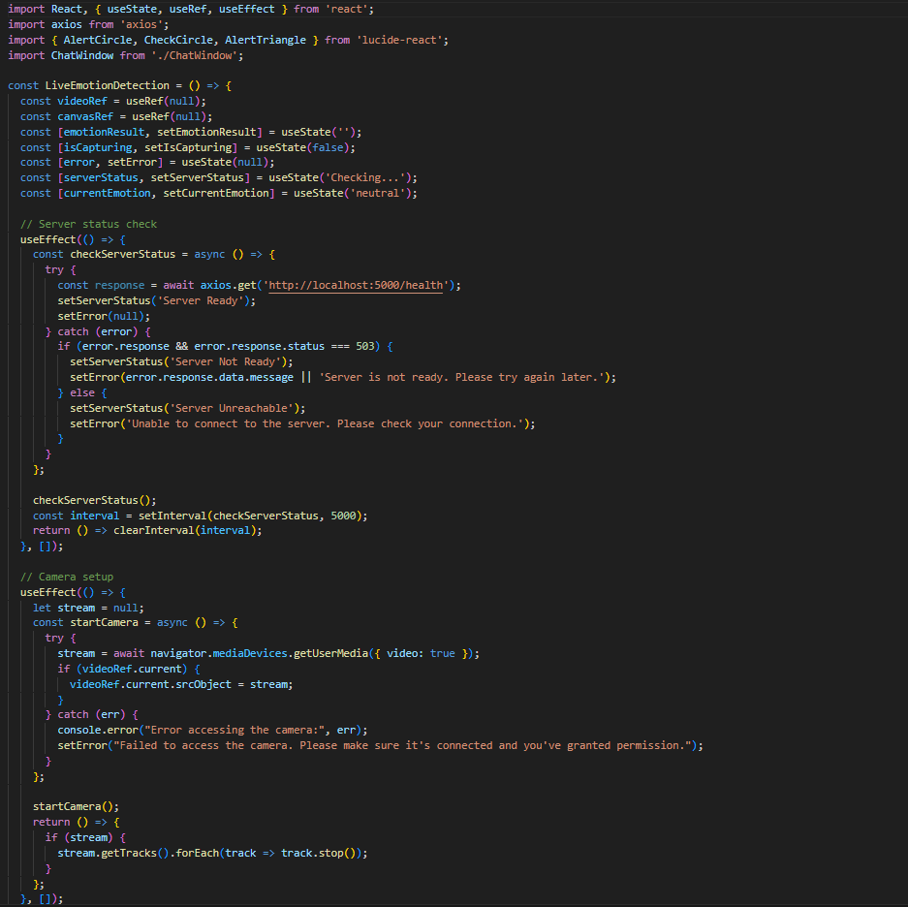

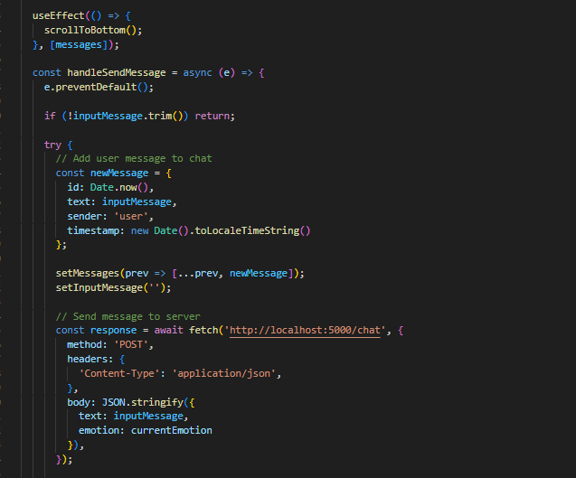
Model Training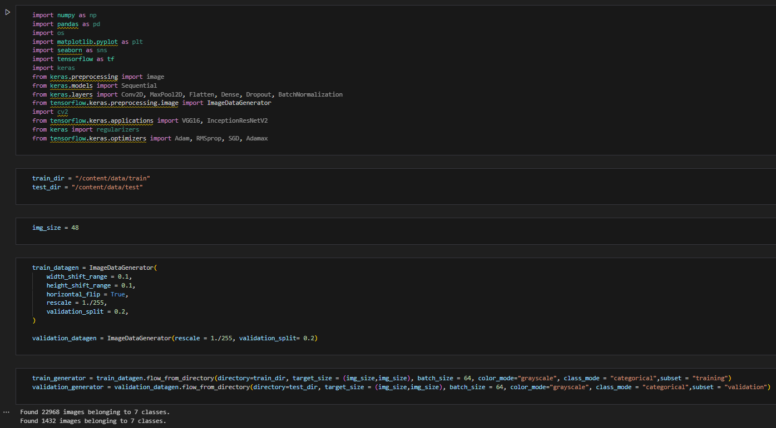

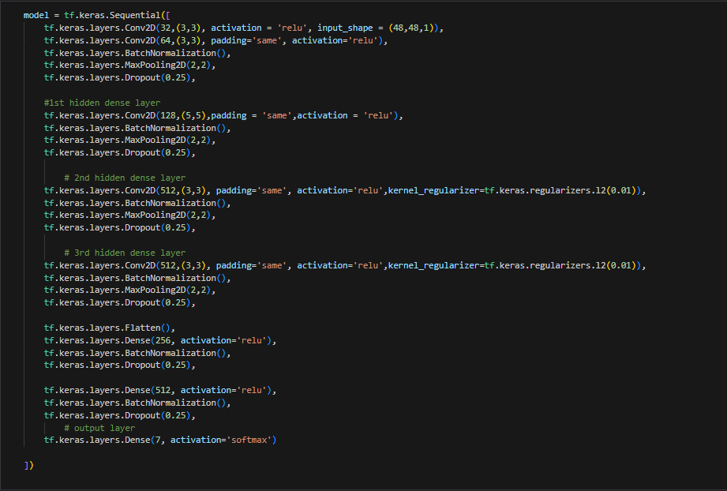
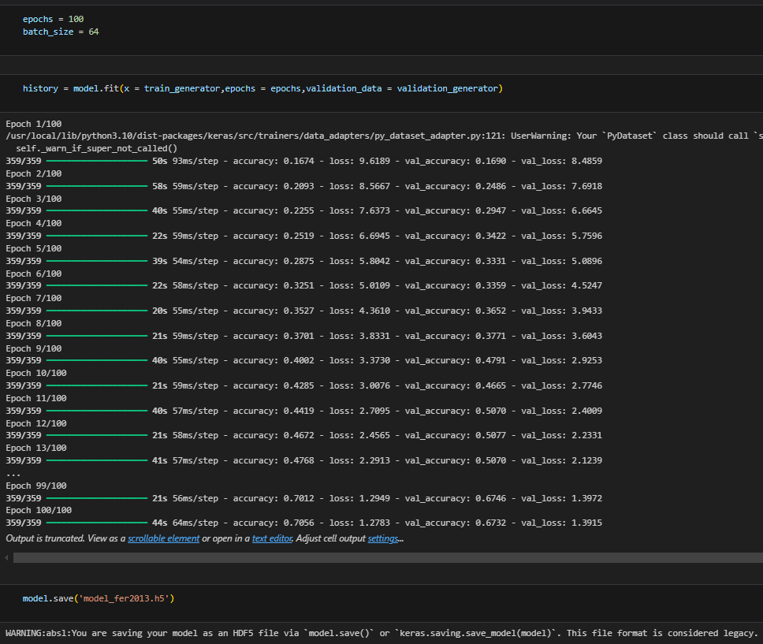

Backend Implementation
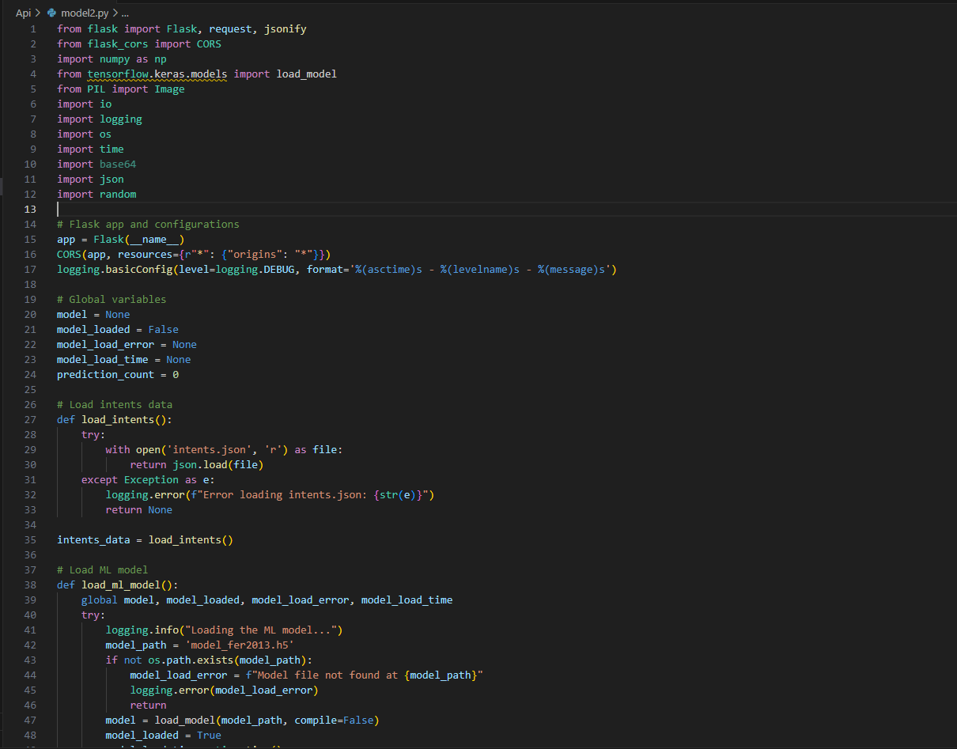
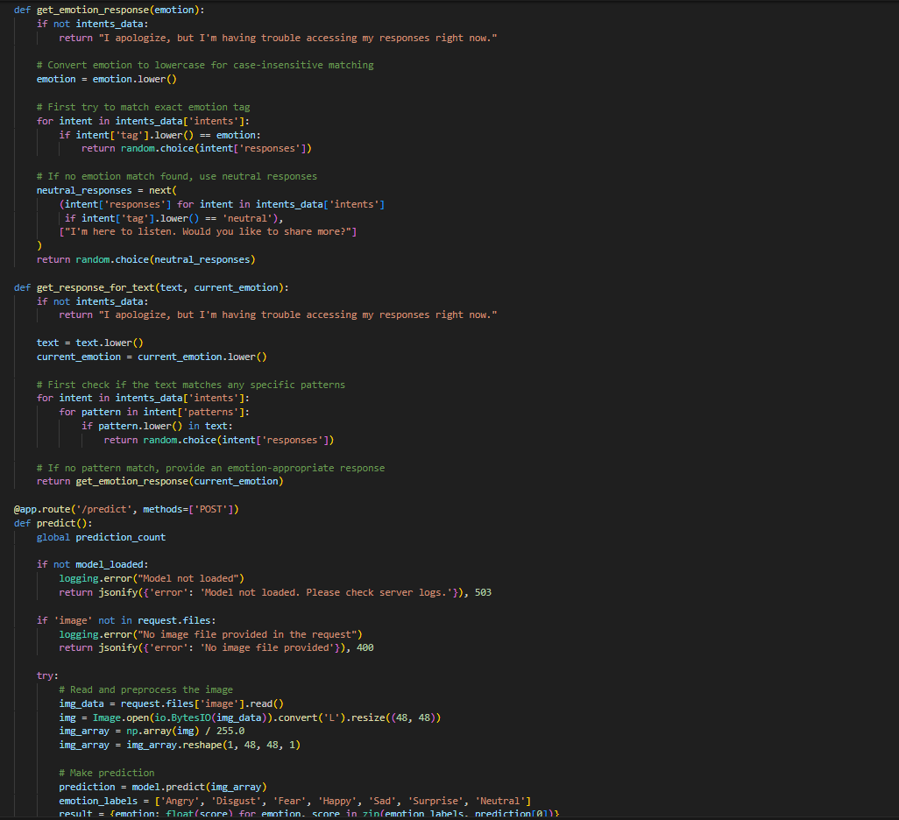
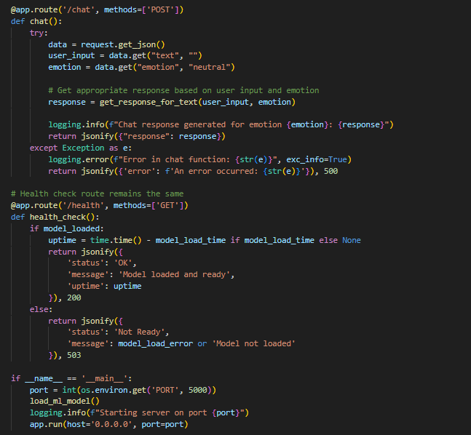
6. Results and Discussion
The evaluation of the system focuses on its performance metrics and user experience insights, demonstrating its efficacy in real-time emotion recognition and adaptive interaction.
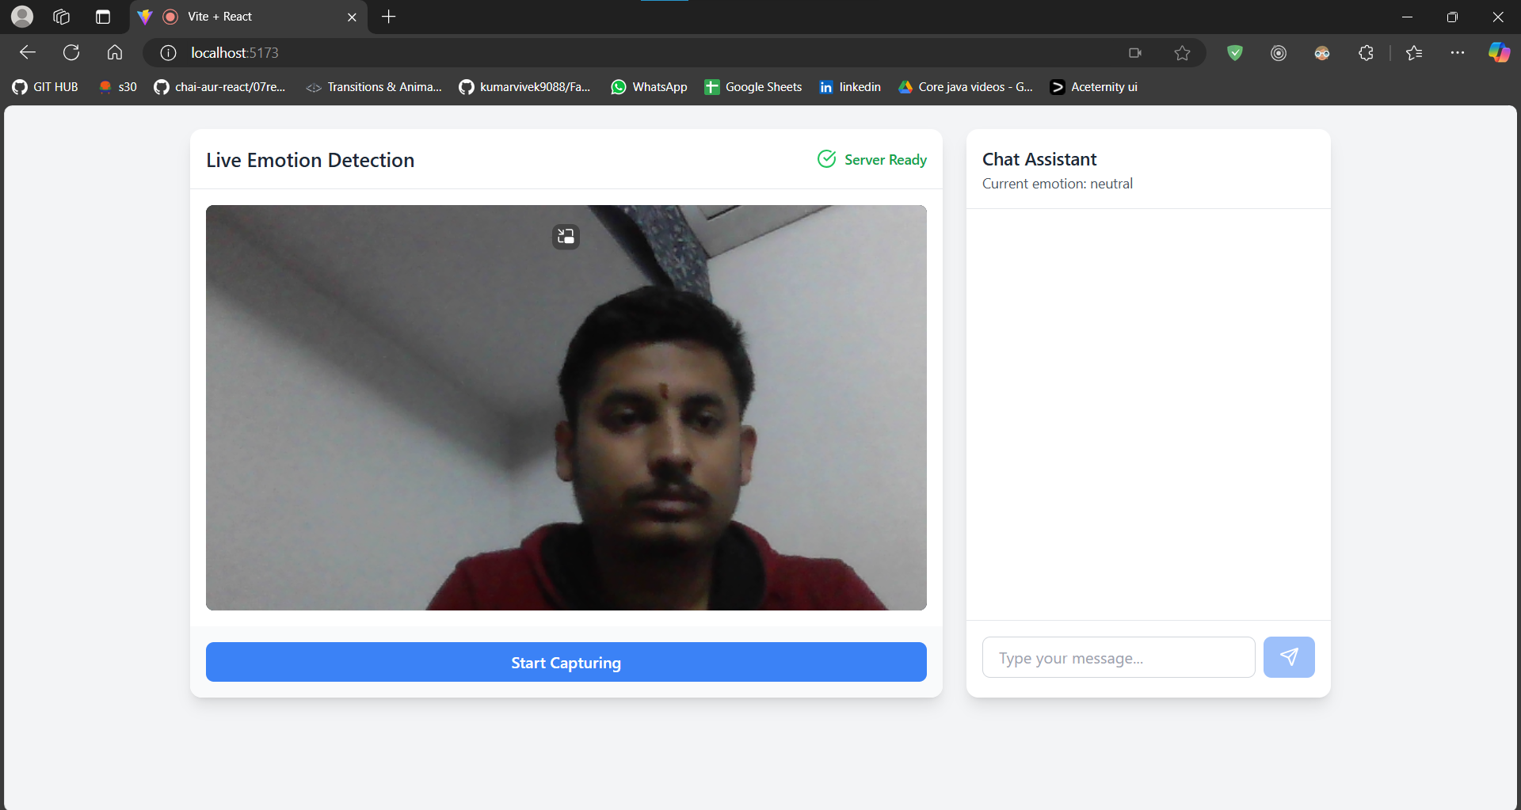
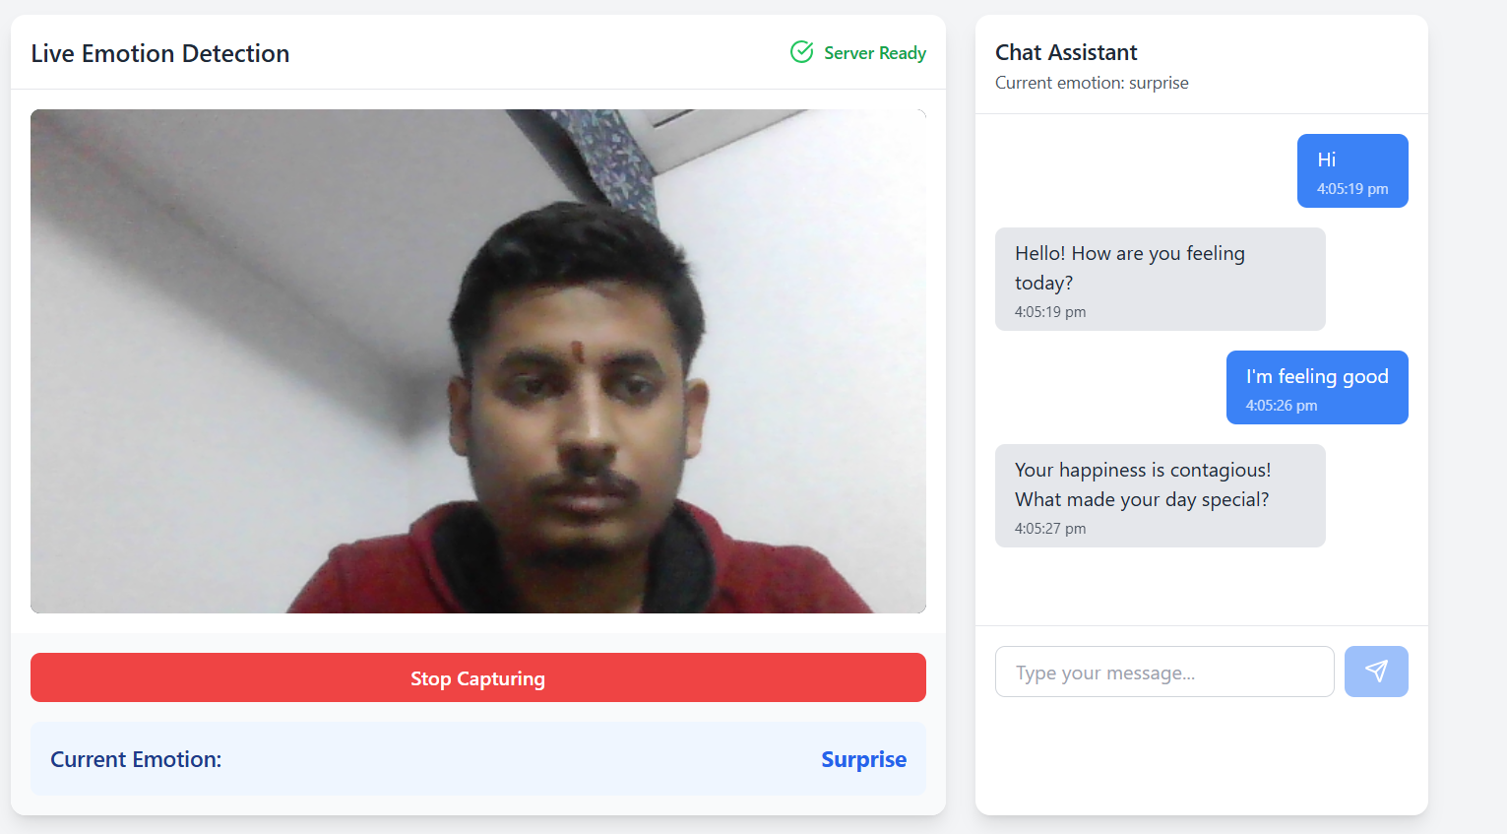

6.1 Performance Metrics
The system's performance was assessed across key operational parameters during extensive testing:
- Emotion Classification Accuracy:
  - Achieved an accuracy of 65-70%, consistent with results reported in similar systems trained on the FER-2013 dataset.
  - Performance varied slightly across emotions:
    - High accuracy for distinct emotions (Happy, Surprise).
    - Lower accuracy for nuanced or overlapping emotions (Fear, Disgust).
- Real-Time Processing Speed:
  - Processed each video frame in under 1 second, ensuring seamless real-time predictions.
  - Optimized preprocessing and model inference steps contributed to low latency, enabling immediate feedback to users.
- Server Reliability:
  - Maintained a 99.5% uptime during testing, with robust error handling and recovery mechanisms.
  - Demonstrated stability under varied workloads, including high-concurrency scenarios.
These metrics indicate the system’s reliability and its potential for integration into real-world applications.
6.2 User Experience Insights
User feedback was gathered to evaluate the system's interface, responsiveness, and emotional intelligence. Key observations include:
- Contextual Understanding:
  - Users noted that the system effectively adapted responses based on both detected emotions and conversational context.
  - The integration of emotion data into the chat interface enhanced engagement and relatability.
- Adaptive Communication:
  - Emotion-specific responses (e.g., empathetic tones for Sad emotions, celebratory tones for Happy) improved user satisfaction.
  - The fallback mechanism ensured fluid interactions even when input patterns deviated from predefined rules.

- Simulation of Emotional Intelligence:
  - The system successfully simulated aspects of emotional intelligence, fostering natural and empathetic interactions.
  - Users reported feeling more understood and engaged, highlighting the potential of emotion
aware systems in domains such as mental health and customer service.

7. Limitations and Future Work
While the system demonstrates strong foundational capabilities, certain limitations and potential enhancements must be addressed to improve its performance and applicability.
7.1 Current Limitations
The following challenges were identified during testing and user feedback sessions:
- Dependency on Front-Facing, Well-Lit Images:
  - The model performs best with images where faces are clearly visible and well-lit.
  - Poor lighting, partial occlusion, or side profiles significantly impact accuracy.
- Limited Emotion Granularity:
  - The system classifies emotions into seven basic categories (Angry, Disgust, Fear, Happy, Sad, Surprise, Neutral), which may oversimplify complex emotional states.
  - Subtle variations, such as a mix of Happy and Surprise, are not effectively captured.
- Potential Bias in Training Data:
  - The FER-2013 dataset, while widely used, may not fully represent global diversity in facial expressions.
  - Cultural and demographic differences can lead to biased predictions, limiting the system’s generalizability.
These limitations highlight areas requiring attention to make the system more robust and inclusive.
7.2 Recommended Improvements
Addressing these limitations involves implementing the following strategies:
- Incorporate More Diverse Training Datasets:
  - Use datasets with broader demographic representation, including variations in age, ethnicity, and cultural expression.
  - Augment data with synthetically generated samples to enhance model robustness under challenging conditions (e.g., low light or occlusion).
- Implement Advanced Emotion Interpolation:
  - Develop models capable of detecting blended or nuanced emotions (e.g., bittersweet, nervous anticipation).
  - Incorporate techniques like attention mechanisms and transfer learning to capture subtle features and improve granularity.
- Develop Sophisticated Response Generation Mechanisms:
  - Enhance the rule-based system by integrating natural language generation (NLG) techniques.
  - Use large language models to produce dynamic, context-aware responses tailored to user emotions and conversation history.
  - Introduce learning-based personalization, enabling the system to adapt its tone and responses to individual users over time.
Future Directions
In addition to addressing current limitations, the following directions can be explored:
- Multimodal Emotion Recognition: Combine facial analysis with speech, text, and physiological signals for a more holistic understanding of user emotions.
- Real-World Testing: Conduct longitudinal studies in diverse environments (e.g., schools, clinics) to assess performance under real-world conditions.
- Ethical Frameworks: Develop transparent guidelines for ethical data usage and bias mitigation, ensuring fairness and user trust.

8. Conclusion
This project presents a novel system for emotion recognition, combining machine learning, real-time analysis, and adaptive communication. By leveraging a convolutional neural network (CNN) trained on the FER-2013 dataset, the system achieves efficient and accurate emotion classification. The integration of a responsive frontend and robust backend facilitates seamless interaction, enabling real-time emotion detection and contextually relevant responses.
Key achievements include:
- Real-Time Processing: Emotion detection and response generation within one second per frame.
- User-Centric Design: A chat interface that adapts responses based on detected emotions, fostering engaging interactions.
- Scalability: A modular architecture that supports further enhancements and broader applications.
Despite challenges like reliance on well-lit images and training data biases, the system lays a solid foundation for future enhancements. Addressing these issues and incorporating multimodal recognition can significantly advance human-computer interactions in fields such as education, healthcare, and customer service. This research highlights the transformative possibilities of emotionally intelligent technologies, paving the way for more empathetic and personalized digital experiences.

9. References

Kaggle : https://www.kaggle.com/datasets/msambare/fer2013
Convolutional Neural Network (CNN) Tutorial
IBM : What is a Neural Network? | IBM
Tensorflow : Convolutional Neural Network (CNN) | TensorFlow Core
GeeksforGeeks : Training of Convolutional Neural Network (CNN) in ... GeeksforGeeks https://www.geeksforgeeks.org › training-of-convolutio...

